Use Dashboard Nodes For Creating UI(Web App)

|  |  |
| --- | --- |
| Date | 10 November 2022 |
| Team Id | PNT2022TMID31893 |
| Title | Hazardous Area Monitoring for  Industrial Plant using IoT |

Node red flow

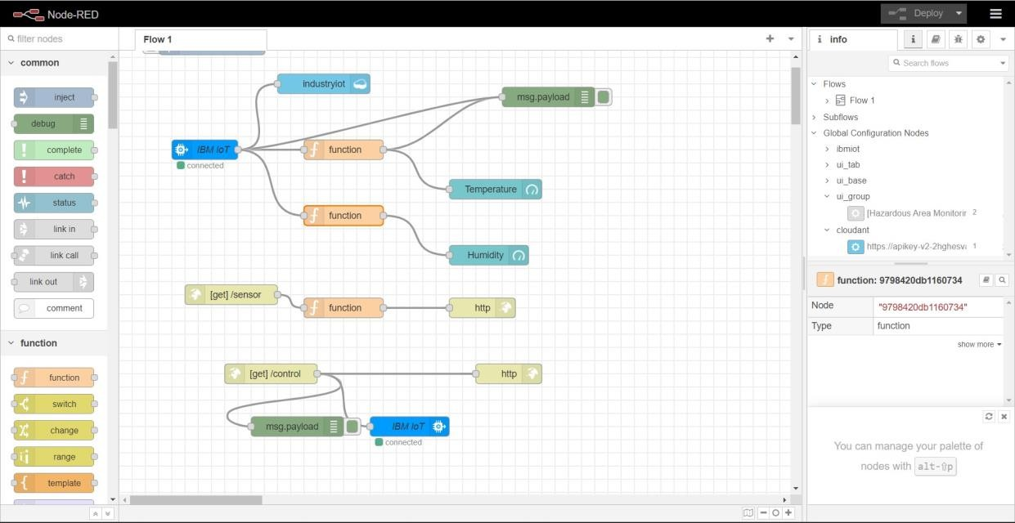

Dashboard configuration

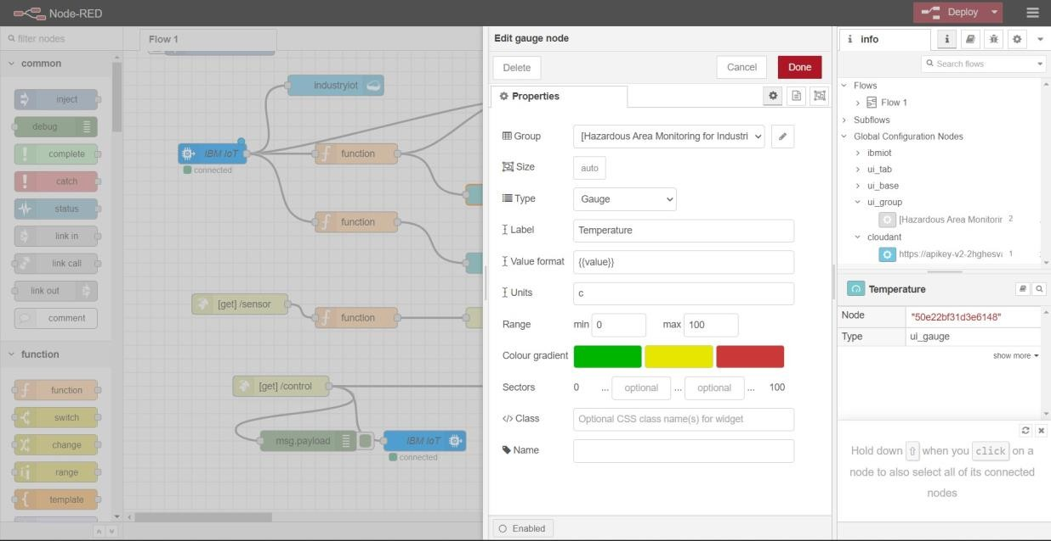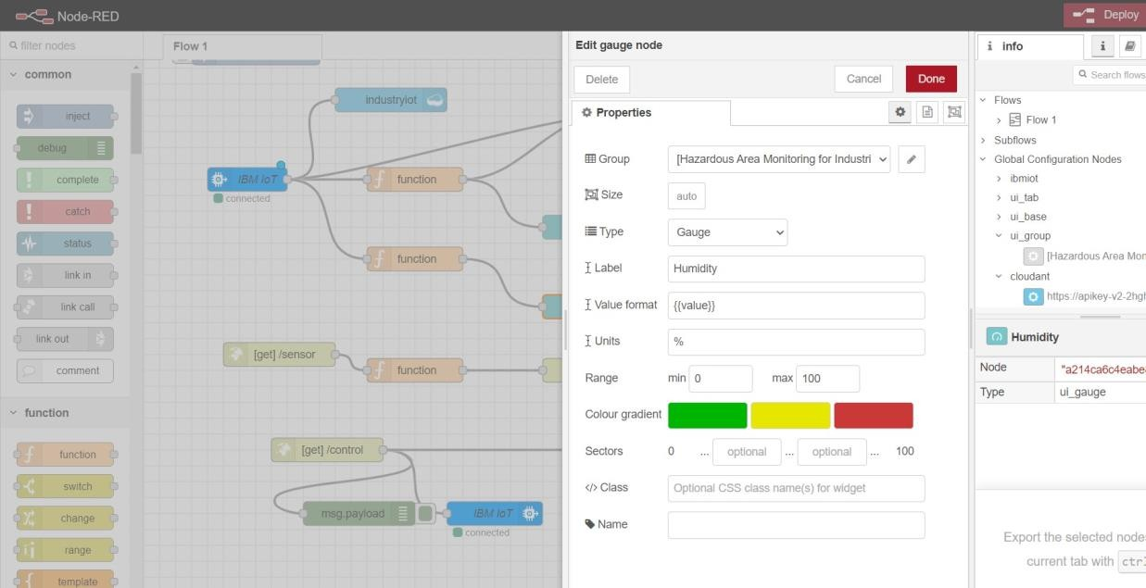

Final Output - Dashboard

